Ideation Phase - Brainstorm & Idea Prioritization
Date | 10 August 2026
Team ID | N/A
Author / Team Member | Ruturaj Misal
Project Name | ShopEZ Ecommerce Application
Maximum Marks | 4 Marks

Brainstorm & Idea Prioritization Template:
Author: Ruturaj Misal
Features were ideated around four pillars: Customer Experience, Merchant Empowerment, Admin Control, and System Scalability. Ideas were evaluated using the Action Priority Matrix (Impact vs. Effort).
Idea / Feature Description | Target User | Impact | Effort | Priority Category | Implementation Decision
JWT Bearer Authentication & Role Access | All Users & Admins | High | Medium | Must Have (Sprint 1) | Implemented using JSON Web Tokens & bcryptjs
Product Catalog with Search & Category Filters | Shoppers | High | Low | Must Have (Sprint 2) | Implemented with MongoDB regex queries & React state
Product Image Upload via Multer | Sellers / Admins | High | Medium | Must Have (Sprint 2) | Implemented with Multer middleware storing in /uploads
Dynamic Cart with Real-time Total Calculations | Shoppers | High | Low | Must Have (Sprint 3) | Implemented via React CartContext & MongoDB Cart model
Cash on Delivery (COD) & Multi-item Checkout | Shoppers | High | Medium | Must Have (Sprint 3) | Implemented with Order schema & shipping address fields
Order Status Tracking (Processing/Shipped/Delivered) | Shoppers & Admins | High | Low | Must Have (Sprint 3) | Implemented with Order status enum and user profile view
Seller Central (`/admin/sell`) with Inline Price/Stock Edit | Sellers | High | Medium | Must Have (Sprint 4) | Implemented with React inline editing and PUT /api/products/:id
Automated Low Stock Warning Banner (< 10 units) | Sellers / Admins | High | Low | Must Have (Sprint 4) | Implemented on Seller Dashboard when stock < 10
Admin Analytics (Total Revenue, Orders, Products, Users) | Platform Admins | High | Medium | Must Have (Sprint 4) | Implemented via MongoDB aggregations in `/api/admin/dashboard`

Action Priority Matrix (Impact vs Effort Diagram):

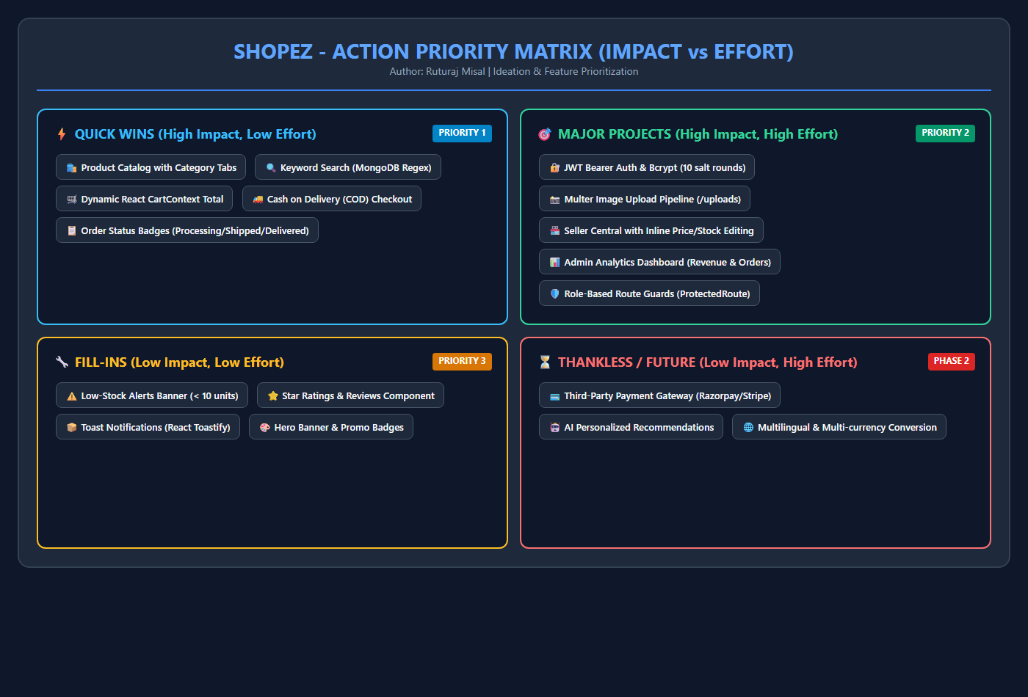
Figure 3: Action Priority Matrix for ShopEZ Feature Set

